Dynamics Processors -- Technology All Together Now...The Big Picture
Figure shows how a gate, expander, compressor and limiter all work together on the same program material in a single channel. The vertical axis is the output level and the horizontal axis is the input level.
Setting all ratios at 1:1 makes the input and output of the circuit the same, as illustrated by the straight diagonal line running at 45° across the graph. Whatever comes in goes out unchanged.
Each of the threshold controls acts like a trigger or hinge point, activating gain reduction or expansion only when the input signal exceeds the set point value.
The ratio controls determine how much of an angle the hinge bends, which is how much gain reduction or expansion occurs above or below the threshold. Graphically, the ratio can swing this hinge from 45° (no processing) to almost 90° (full ratio). It is also possible, by adjusting the threshold controls, to have each of these circuits overlap and interact with each other to develop a dynamic curve. The solid black line shows the resultant curve.
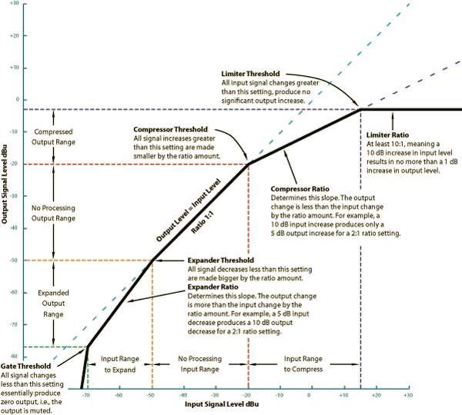
Figure 25. Gate, Expander, Compressor and Limiter All Together.

Compressor & Peak Limiter Application Tips
Forewarning
Like spice in cooking, a little goes a long way. The problem with heavy compression (low threshold and a high ratio) is the nasty side effects. The timbre of the sound itself changes: it becomes hard and closed, not sweet and open as intended. Breathing and pumping can accompany heavy compression, i.e., the background noise rises way out of proportion to the foreground sound as the compressor releases.
Controlling Live Sound Levels
For smoothing level variations between different microphones, use a low compression ratio of 2:1. For line-level averaging, use a higher ratio of 4:1. Initially set the threshold control at 0 dBu, set a ratio of 3:1 and rotate the release control to the middle setting (or auto mode if available) and bring the system level up to 0 dBu (using a recorded source or during rehearsal). Increase the level until the meters respond showing the amount of compression in dB. Experiment with different ratio settings as well as attack and release times (or auto-set mode, if provided).
Vocals
A tough issue with vocals is the extreme dynamic range of some singers: those who lull you to sleep and then crush you with an unexpected blast. The difference between the soft crooning and the loud climax represents too great a signal change for many preamps and mixers, causing them to clip and distort. For solo vocals the concern is keeping the signal level within the operating range of the equipment -- keeping the quiet parts above the noise floor while keeping the loud parts below the clipping level.
Things get more difficult when the singer in no longer a solo act and has a group of amplified musicians accompanying. The challenge is to keep the vocal(s) prominent while keeping them within a comfortable level compared to the rest of the musicians. If you were to leave the vocal microphones at a high enough gain so that the quiet parts are easily heard, the loud parts might flow forth with far too much level and drown out the rest of the band.
The key is to reduce the vocals dynamic range to something comparable to that of the musicians' instruments. Relatively heavy compression is often used in this scenario, either by using a low ratio (2:1) with a lower threshold (-12 dB) or a higher ratio (4:1) with a higher threshold (-9 dB, or so). Typically set the threshold so that quiet vocal passages show little or no gain reduction and normal singing shows between 3 dB to 6 dB gain reduction when using a 2:1 ratio.
A soft knee characteristic is typically more "musical" sounding with vocals. As an added bonus, a soft knee setting allows using higher ratios since the transition from 1:1 to higher ratios is gradual. This allows the compressor to function more aggressively as the input level rises and you need to clamp down on the signal harder.
Experimentation is the key here; there is no magic setting, but these are good starting points.
When recording vocals use a compressor to reduce the dynamic range of the whole piece to fit the recording or reproduction requirements. Even a small amount of compression makes the whole track sound louder. This increase in perceived loudness results from increasing the average gain by reducing the peaks, i.e., it has a higher average level. This is one of the tricks for bringing the vocals up in any mix, live or recorded.
Good settings for natural sounding, yet compressed vocals, are a medium fast (25 - 50 ms) attack and a medium-slow (100 ms - 1 sec) release. Releasing too quickly sounds unnatural while attacking too slow misses the problem surges.
Bass
It is common for the sound mixer to reduce the bass signal because it overwhelms the total system. Use a compressor to smooth a bass sound by lessening the variations between the strings and increasing the sustain.
Typical settings for a bass guitar are a ratio of 4:1, with a fast attack of 25 ms and a slow release of around 500 ms. These settings produce a strong, smooth bass line to start with, and then adjust further as necessary. A hard knee setting is often preferred since all you want is to tame the excessive peaks and leave everything else alone.
Placement of the compressor in the signal chain depends on how you want it to function. For just the input signal, it goes after the bass guitar (if it has a line-level output) and before the preamp. If it is to function as a limiter to protect the speakers in the bass rig, it goes between the preamp and the power amp. Another method is to insert the unit into the effects loop of the preamp. This affects the bass signal by the preamp first, then the compressor limiter, and finally out to the power amp.
Guitar
Here are a few suggestions on how to achieve a lower volume without sounding as if you are playing out of a transistor radio. Set a slow (~500 ms) attack time with a medium to slow (100 ms – 500 ms) release and a relatively low threshold. Experiment from these initial settings. Do not over compress the high frequencies or the pick attack will sound slurred.
One of the favorite uses of compression by guitarist is to increase the sustain, or duration of a note after it is played. Jeff Beck, Carlos Santana and Gabor Szabo used sustain to great acclaim, although they did it the old-fashioned way of creating feedback by aiming the guitar pick-ups at the loudspeaker and then jamming over it (using a hard limiter to prevent damage). A compressor creates a similar effect. Set a high ratio and low threshold for long sustain, along with fast attack and slow release. Again, experimentation produces the best results.
Drums
When using compressors on drums and percussion, it is polar opposite time. Two popular approaches exist for changing the sound character. Both yield pleasant results and allow you to dramatically or subtly change the nature of the sound. Regardless of which approach you try or end up liking, the vast majority of compressor use on drums is limited to snare and bass drum.
The first approach is to use the attack time of the compressor to modify the drum sound. For example, by using a slower attack time along with a 2:1 ratio on a snare drum and by varying the threshold you can make very dramatic changes in the tonal character. By using a slower attack time the initial "crack" of the drum gets through -- great if the drum heads are old. This was a very popular technique for getting a beefy consistent snare sound for many years and is heard on many rock ballads. By only adjusting the attack time and ratio you will be amazed at how many variations of tone are possible, even without a stitch of EQ.
Reducing the leading edge of drum hits is another popular use of compressors. Try ratios between 2:1 and 5:1 accompanied by fast attack and release times. Listen carefully while changing the attack time to find the final setting.
Cymbals need a fast attack but a slow release to allow the sustain through. Begin with a low ratio of 2:1.
Bass drums are difficult to capture consistently due to drumming technique and other issues. It is common to use a compressor to keep the bass drum at a consistent level and tonality. Since many mixes are created with the rhythm section as the foundation, it is important to keep those elements even and consistent. This involves higher ratios (between 4:1 and 10:1) with a fast attack and release time.
To prevent turning the drum sound into pure mush, it is important to use a monitoring system (or the main sound system) having good low frequency performance. Use high ratios to keep the level consistent, and use the fastest attack possible without destroying the drum punch.
Recording
Compressors find use primarily on bass guitar, piano, drums and vocals. Another popular application is the drum mix or submix.
For digital recording use it to compress a too-wide dynamic range into a signal that does not cause digital overload. The limiter is the primary circuit for keeping things under control, but a little compression with its threshold set just under the limiter threshold helps keep the limiting subtle. To control a stereo mix, use the side-chain slave mode.
Suggested Compressor Settings
The following chart shows starting points:
 | ATTACK | RELEASE | RATIO | KNEE
Vocals | 25 ms to 100 ms | 100 ms to 500 ms | 2:1 to 4:1 | Soft
Clicky Bass | 25 ms | 25 ms | 4:1 or higher | Hard
Mushy Bass | 100 ms to 500 ms | 100 ms to 500 ms | 4:1 | Hard
Raging Electric Guitar | 25 ms | 1 sec - 2 sec | 4:1 or higher (more sustain) | Hard
Acoustic Guitar | 100 ms to 500 ms | 100 ms to 500 ms | 4:1 | Medium
Brassy Horns | 25 ms | 25 ms | 5:1 or higher | Hard
Drums (kick, snare) | 25 ms | 25 ms | 4:1 | Hard
Drums (cymbals) | 25 ms | 1 sec - 2 sec | 2:1 to 10:1 | Hard
Suggested Compressor Settings
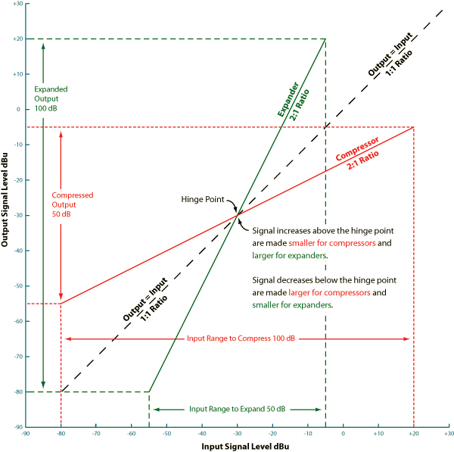
Figure 29. Classic Compressor and Expander Operation

